

**FACULTY: APPLIED AND COMPUTER SCIENCE DEPARTMENT: SOFTWARE STUDIES**

**ASDSX3A – Development Software 3.1 Assignment 2 Due DATE : Wk Ending 13 March**

**TOTAL: 200 Marks EXAMINER: S. MOYO MODERATOR: MRS RT MNGOMA**

**Overall Purpose**

The relational database **AdelaneFashionsDB** contains a table (tblAdelaneFashions) with information about Adalene Fashions business. A 3-tier design application with **Problem domain**, **Data Access** and **GUI** classes is required that allows the user to view the information in the dataset, update specified records, remove specified records and add details about a new store to the database by clicking on various buttons. Name the problem domain and data access classes, **AdelaneFashionsPD** and **AdelaneFashionsDA** respectively.

**Problem Domain class specification**

The class stores a store number, city, province, ownership and sales; (see **AdelaneFashionsDB**.txt). Code the default constructor parametrized constructor, setters, getters and the toString() method in this class. The **province** and the **ownership** must be enumerators. The **province** must be an enumerator with values: GP, MP, NW, etc. (include all the South African provinces), and **ownership** must be an enumerator with values: C and F for company-owned and Franchisee stores. Validate the sales field appropriately. (40)

**Data Access class specification**

Code the following methods:

* + A method **initConnection()** for connecting to the **AdelaneFashionsDB**. (7)
  + A method **terminate()** for closing the connection established by the **initConnection()** method. (3)
  + Method **returnAllData()** to return all of the information in the dataset using an arraylist.(group the information by ownership). (11)
  + Method **returnProvince()** to retrieve and return all stores located in the specified province using an arraylist. The method receives the province as a parameter. (11)
  + Return the total sales in the database using the method **CalculateTotalSales().** (5)
  + Return the total sales made by company-owned stores using the **CalculateTotalCompanyOwnedSales().**

(5)

* + Return the total sales made by franchisees using the **CalculateTotalFranchiseeSales().** (5)
  + Method **removeStore()** deletes a store whose store number is sent as a parameter to the to it. (5)
  + Method **addNewStore()** adds the details of a new store to the data storage. (6)
  + Method **increasePrices()** increases the prices of all franchisee stores in Gauteng by a given percentage. The method receives the percentage as an integer ( eg. 20 for 20%). (5)

**GUI - Specific requirements.**

The application consists of two separate user interfaces the **AdelaneFashionsFrame** and the **DataManipulationScreen** shown in **Figure 1** and **Figure 2** respectively**.**

* Write code in the **AdelaneFashionsScreenLoader** class’s main method to always load the main form (**AdelaneFashionsFrame)** when this project is run and set its title to: “ Adelane Fashions Stores”. (3)
* Establish the connection when the main form is loaded. Also display all the 9 provinces in the combo box as shown in Figure 3. (2)
* The **Display All** button displays all the information from the data base with appropriate headings as in Figure 4. (5)
* When the user selects a province from the combo box, all the records associated with that province should be displayed in the text area. (7)
* When the user clicks on the **Calculate** button, the three totals (total sales for the dataset, total sales for company owned stores and total sales for franchisees) are displayed on their respective labels on the **Total Sales** panel. (8)
* The button M**ore Options** at the bottom displays the DataManipulationScreen and sets its title as **Adelane Fashions Data Manipulation Screen**. (3)
* When the DataManipulationScreenform first loads, the combo box is populated with integers from 100 to 130 and the provinces combo box populated with provinces. Populate the combo boxes. (5)
* Code the **Register New Store** to get data from the controls, create an object of the AdelaneFashionsPD and call the appropriate method to copy the record to the database. (21)
* The **Delete Store** reads the selected store number from the combo box and calls the appropriate method to delete the record. (7)
* The **Increase GP** **Prices** gets input using an input box and pass it to the method that increases the prices of all franchisee stores in Gauteng province. ()

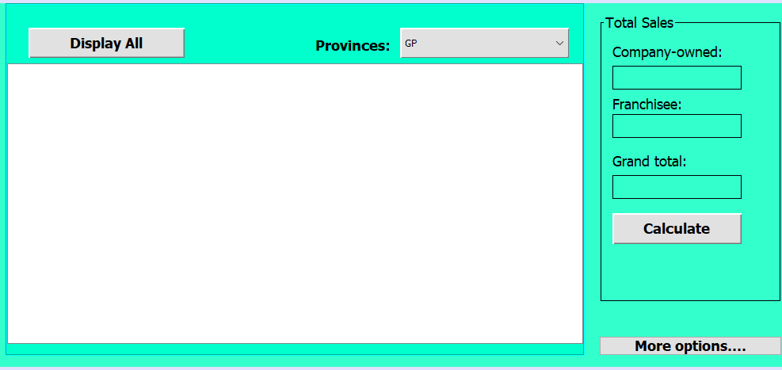 Fig1 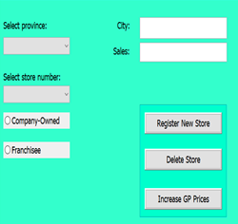Fig2

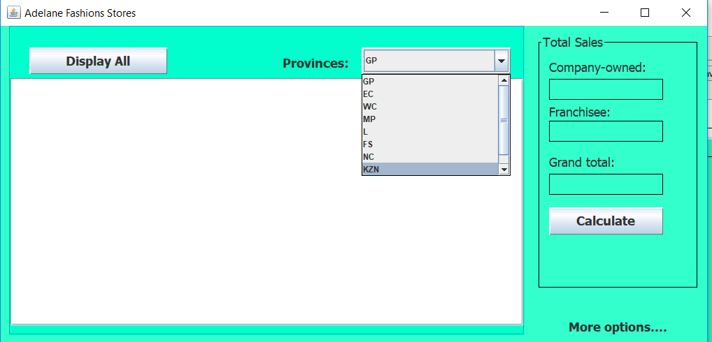Fig 3

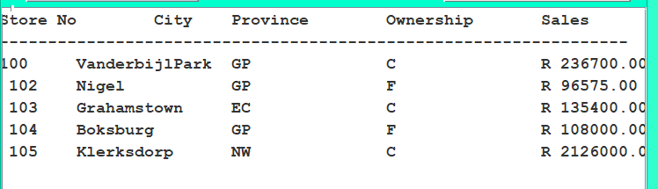Fig 4 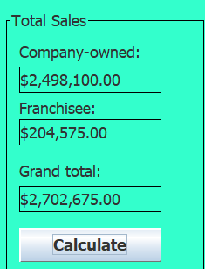Fig 5

**………………………………………….Good Luck…………………………………………………**